Huffman coding – Greedy Algorithm
:is a compression algo that uses greedy choice property to compress data so that it doesnt loose any information.
Huffman coding is data compression algo, that drives to compress data in a lossless form.

Based on lengths of assigned codes based on frequencies themselves.
Variable length codes are known as Prefix codes.
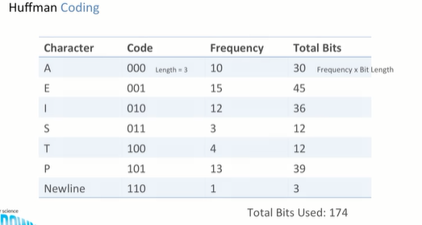

Goal: Try to reduce the total number of bits used without losing any information.

Code Tree:
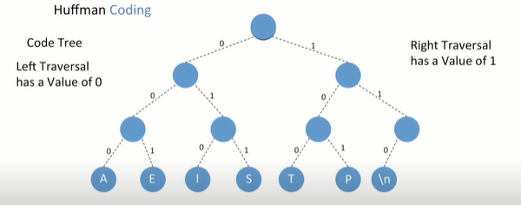
So Above, we want to find the char code for p, I traverse down the right branch adding 1 to the code, then I traverse down once from the left branch from that node, adding a 0, then I traverse down again from that node , adding a 1 to the code and getting to p.

P:101

Goal: Reduce the code Tree.

So here we wanna reduce the traversal through the node tree, so that the nodes with highest frequency value.

Step1 :
Take the 2chars with the lowest frequency
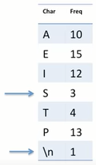

Step 2: Make a two leaf node tree for them
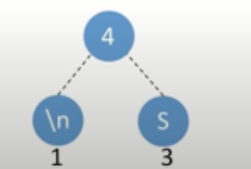
The root node holds a value and the value is some of the frequency of the nodes beneath.
So 1+3=4;

we can treat this sub-tree as individual node with a frequency value of 4.

We are done with s and \n, so we scratch them off our list.

Step 3: Take the next lowest frequency char, and add it to the tree
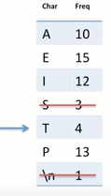

so, we create a node for T and put his frequency value beneath and create a parent node, which has a value of frequency of node T + value of frequency of the entire right sub-tree. So I.e 4+4=8;

we are done using T we can scratch them off our list
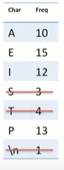
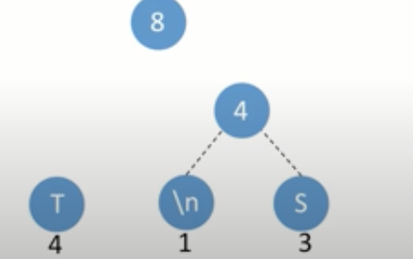

So, next char is A. so we create a node A and put his ……
So I.e 10+8=18
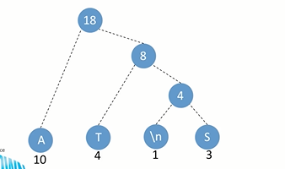
but hold it
18 is really high, its higher than all the 3 remaining characters in the list.

So we can’t no-longer add to this sub-tree, so we have to create a new sub-tree using the next two lowest characters.
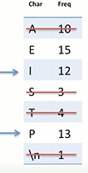
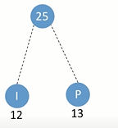

Now, we have 1 node is left
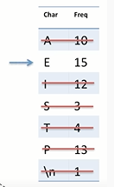

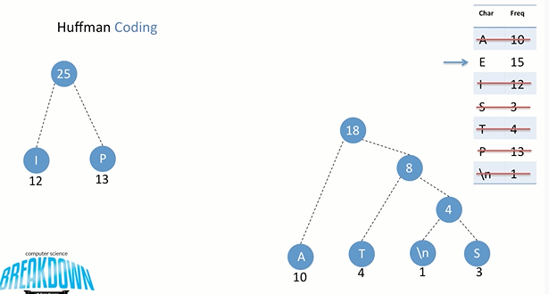

now I create a the node E, with its frequency value beneath, now I create the parent node with frequency value of 33.

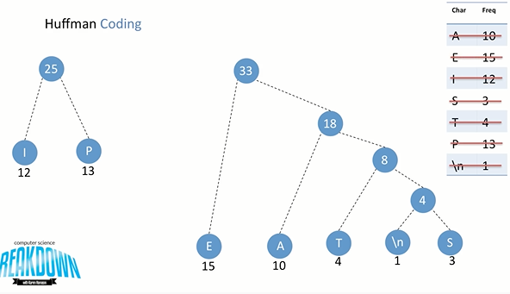

so now we are done with E, we are scratching it off our list. So we are no-longer adding any leaf nodes characters in our tree.

But we are still left with two subtree, that we need to connect together to form one large tree.
So we connect the two sub-tree, now having a parent node with a frequency I.e
25+33=58;

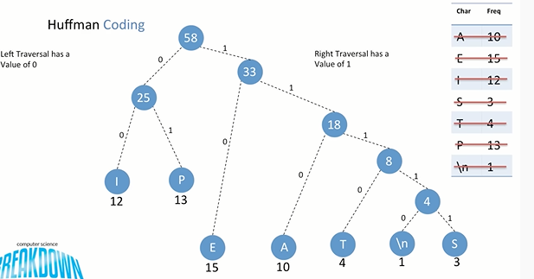
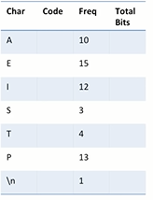
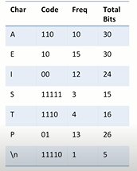
--→
We have longer code for s and \n cuz they are seldom(rare,infrequent) used

